from google.colab import files
dataset = files.upload()
<IPython.core.display.HTML object>
Saving Churn_Modelling.csv to Churn_Modelling.csv

Importing Required Packages
import pandas as pd
import seaborn as sns
import numpy as np
from matplotlib import pyplot as plt
%matplotlib inline

Previewing Dataset
df = pd.read_csv("Churn_Modelling.csv")
df.head()
RowNumber CustomerId Surname CreditScore Geography Gender Age \
0 1 15634602 Hargrave 619 France Female 42
1 2 15647311 Hill 608 Spain Female 41
2 3 15619304 Onio 502 France Female 42
3 4 15701354 Boni 699 France Female 39
4 5 15737888 Mitchell 850 Spain Female 43
Tenure Balance NumOfProducts HasCrCard IsActiveMember \
0 2 0.00 1 1 1
1 1 83807.86 1 0 1
2 8 159660.80 3 1 0
3 1 0.00 2 0 0
4 2 125510.82 1 1 1
EstimatedSalary Exited
0 101348.88 1
1 112542.58 0
2 113931.57 1
3 93826.63 0
4 79084.10 0

Visualizations - Uni-Variate Analysis
sns.displot(df.Tenure)
<seaborn.axisgrid.FacetGrid at 0x7f7ac92ff390>
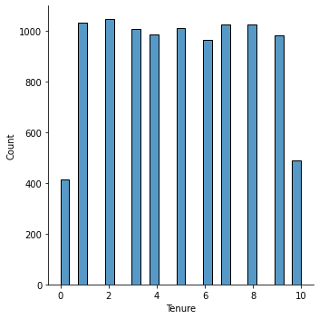

Bi-Variate Analysis
df.plot.line()
<matplotlib.axes._subplots.AxesSubplot at 0x7f7ac8fcded0>
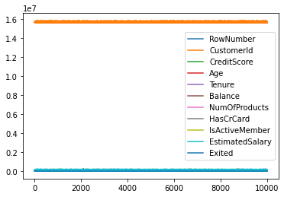

Multi-Variate Analysis
sns.lmplot("Age", "NumOfProducts", df, hue="NumOfProducts", fit_reg=False)
/usr/local/lib/python3.7/dist-packages/seaborn/_decorators.py:43: FutureWarning: Pass the following variables as keyword args: x, y, data. From version 0.12, the only valid positional argument will be `data`, and passing other arguments without an explicit keyword will result in an error or misinterpretation.
FutureWarning
<seaborn.axisgrid.FacetGrid at 0x7f7ac60cb090>
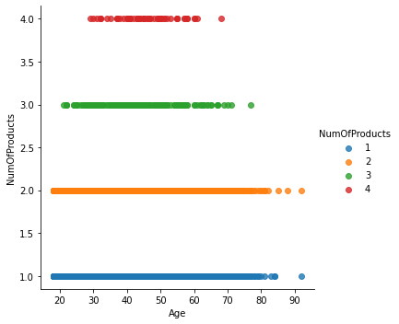

Descriptive Statistics on dataset
df.describe()
RowNumber CustomerId CreditScore Age Tenure \
count 10000.00000 1.000000e+04 10000.000000 10000.000000 10000.000000
mean 5000.50000 1.569094e+07 650.528800 38.921800 5.012800
std 2886.89568 7.193619e+04 96.653299 10.487806 2.892174
min 1.00000 1.556570e+07 350.000000 18.000000 0.000000
25% 2500.75000 1.562853e+07 584.000000 32.000000 3.000000
50% 5000.50000 1.569074e+07 652.000000 37.000000 5.000000
75% 7500.25000 1.575323e+07 718.000000 44.000000 7.000000
max 10000.00000 1.581569e+07 850.000000 92.000000 10.000000
Balance NumOfProducts HasCrCard IsActiveMember \
count 10000.000000 10000.000000 10000.00000 10000.000000
mean 76485.889288 1.530200 0.70550 0.515100
std 62397.405202 0.581654 0.45584 0.499797
min 0.000000 1.000000 0.00000 0.000000
25% 0.000000 1.000000 0.00000 0.000000
50% 97198.540000 1.000000 1.00000 1.000000
75% 127644.240000 2.000000 1.00000 1.000000
max 250898.090000 4.000000 1.00000 1.000000
EstimatedSalary Exited
count 10000.000000 10000.000000
mean 100090.239881 0.203700
std 57510.492818 0.402769
min 11.580000 0.000000
25% 51002.110000 0.000000
50% 100193.915000 0.000000
75% 149388.247500 0.000000
max 199992.480000 1.000000

Handle the missing values
data = df
pd.isnull(data["Gender"])
0 False
1 False
2 False
3 False
4 False
...
9995 False
9996 False
9997 False
9998 False
9999 False
Name: Gender, Length: 10000, dtype: bool

Find the outliers and replace the outliers
df["Tenure"] = np.where(df["Tenure"] > 10, np.median, df["Tenure"])
df["Tenure"]
0 2
1 1
2 8
3 1
4 2
..
9995 5
9996 10
9997 7
9998 3
9999 4
Name: Tenure, Length: 10000, dtype: object

Check for Categorical Columns and Perform Encoding
pd.get_dummies(df, columns = ["Gender", "Age"], prefix = ["Age", "Gender"]).head()
RowNumber CustomerId Surname CreditScore Geography Tenure Balance \
0 1 15634602 Hargrave 619 France 2 0.00
1 2 15647311 Hill 608 Spain 1 83807.86
2 3 15619304 Onio 502 France 8 159660.80
3 4 15701354 Boni 699 France 1 0.00
4 5 15737888 Mitchell 850 Spain 2 125510.82
NumOfProducts HasCrCard IsActiveMember ... Gender_78 Gender_79 \
0 1 1 1 ... 0 0
1 1 0 1 ... 0 0
2 3 1 0 ... 0 0
3 2 0 0 ... 0 0
4 1 1 1 ... 0 0
Gender_80 Gender_81 Gender_82 Gender_83 Gender_84 Gender_85 \
0 0 0 0 0 0 0
1 0 0 0 0 0 0
2 0 0 0 0 0 0
3 0 0 0 0 0 0
4 0 0 0 0 0 0
Gender_88 Gender_92
0 0 0
1 0 0
2 0 0
3 0 0
4 0 0
[5 rows x 84 columns]

Split the data into Dependent and Independent Variables

Split the data into Indepenedent Variables
X = df.iloc[:, :-2].values
print(X)
[[1 15634602 'Hargrave' ... 1 1 1]
[2 15647311 'Hill' ... 1 0 1]
[3 15619304 'Onio' ... 3 1 0]
...
[9998 15584532 'Liu' ... 1 0 1]
[9999 15682355 'Sabbatini' ... 2 1 0]
[10000 15628319 'Walker' ... 1 1 0]]

Split the data into Dependent Variables
Y = df.iloc[:, -1].values
print(Y)
[1 0 1 ... 1 1 0]

Scale the Independent Variables
import pandas as pd
from sklearn.preprocessing import MinMaxScaler
scaler = MinMaxScaler()
df[["RowNumber"]] = scaler.fit_transform(df[["RowNumber"]])
df
RowNumber CustomerId Surname CreditScore Geography Gender Age \
0 0.0000 15634602 Hargrave 619 France Female 42
1 0.0001 15647311 Hill 608 Spain Female 41
2 0.0002 15619304 Onio 502 France Female 42
3 0.0003 15701354 Boni 699 France Female 39
4 0.0004 15737888 Mitchell 850 Spain Female 43
... ... ... ... ... ... ... ...
9995 0.9996 15606229 Obijiaku 771 France Male 39
9996 0.9997 15569892 Johnstone 516 France Male 35
9997 0.9998 15584532 Liu 709 France Female 36
9998 0.9999 15682355 Sabbatini 772 Germany Male 42
9999 1.0000 15628319 Walker 792 France Female 28
Tenure Balance NumOfProducts HasCrCard IsActiveMember \
0 2 0.00 1 1 1
1 1 83807.86 1 0 1
2 8 159660.80 3 1 0
3 1 0.00 2 0 0
4 2 125510.82 1 1 1
... ... ... ... ... ...
9995 5 0.00 2 1 0
9996 10 57369.61 1 1 1
9997 7 0.00 1 0 1
9998 3 75075.31 2 1 0
9999 4 130142.79 1 1 0
EstimatedSalary Exited
0 101348.88 1
1 112542.58 0
2 113931.57 1
3 93826.63 0
4 79084.10 0
... ... ...
9995 96270.64 0
9996 101699.77 0
9997 42085.58 1
9998 92888.52 1
9999 38190.78 0
[10000 rows x 14 columns]

Split the data into Training and Testing Sets
from sklearn.model_selection import train_test_split
train_size = 0.8
X = df.drop(columns = ["Tenure"]).copy()
y = df["Tenure"]
X_train, X_rem, y_train, y_rem = train_test_split(X, y, train_size = 0.8)
X_valid, X_test, y_valid, y_test = train_test_split(X_rem, y_rem, test_size=0.5)
print(X_train.shape), print(y_train.shape)
print(X_valid.shape), print(y_valid.shape)
print(X_test.shape), print(y_test.shape)
(8000, 13)
(8000,)
(1000, 13)
(1000,)
(1000, 13)
(1000,)
(None, None)

